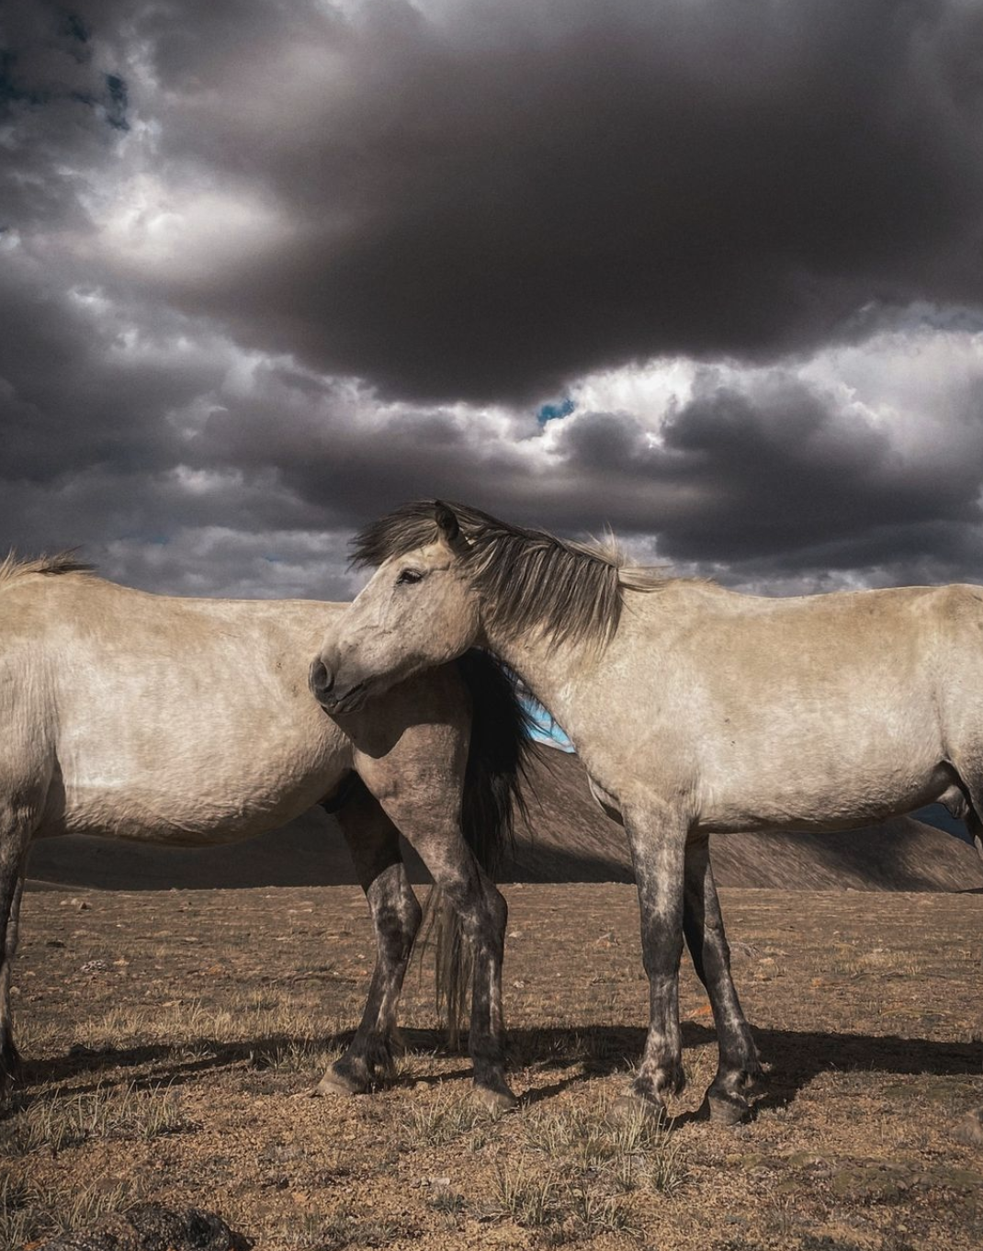

**Caption** : there are two horses standing together in a field under a cloudy sky

**Creative Caption**: “The sky may be cloudy, but these two horses are still standing strong in the field ”

**Hashtags**: #horses #equire #horseandclouds and #cloudyday

2.

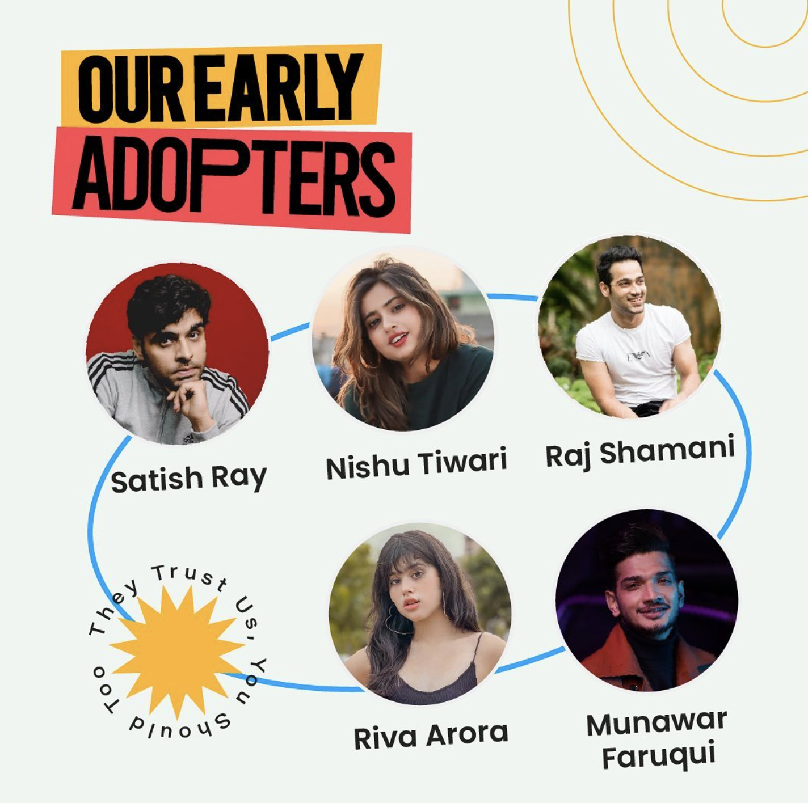

**Caption** : a poster with the names of the different actors

**Creative Caption** : "Who's Who of Hollywood"

**Creative hashtags** : #actors #movie #tv #film #theater #show #star #name #famous

3.

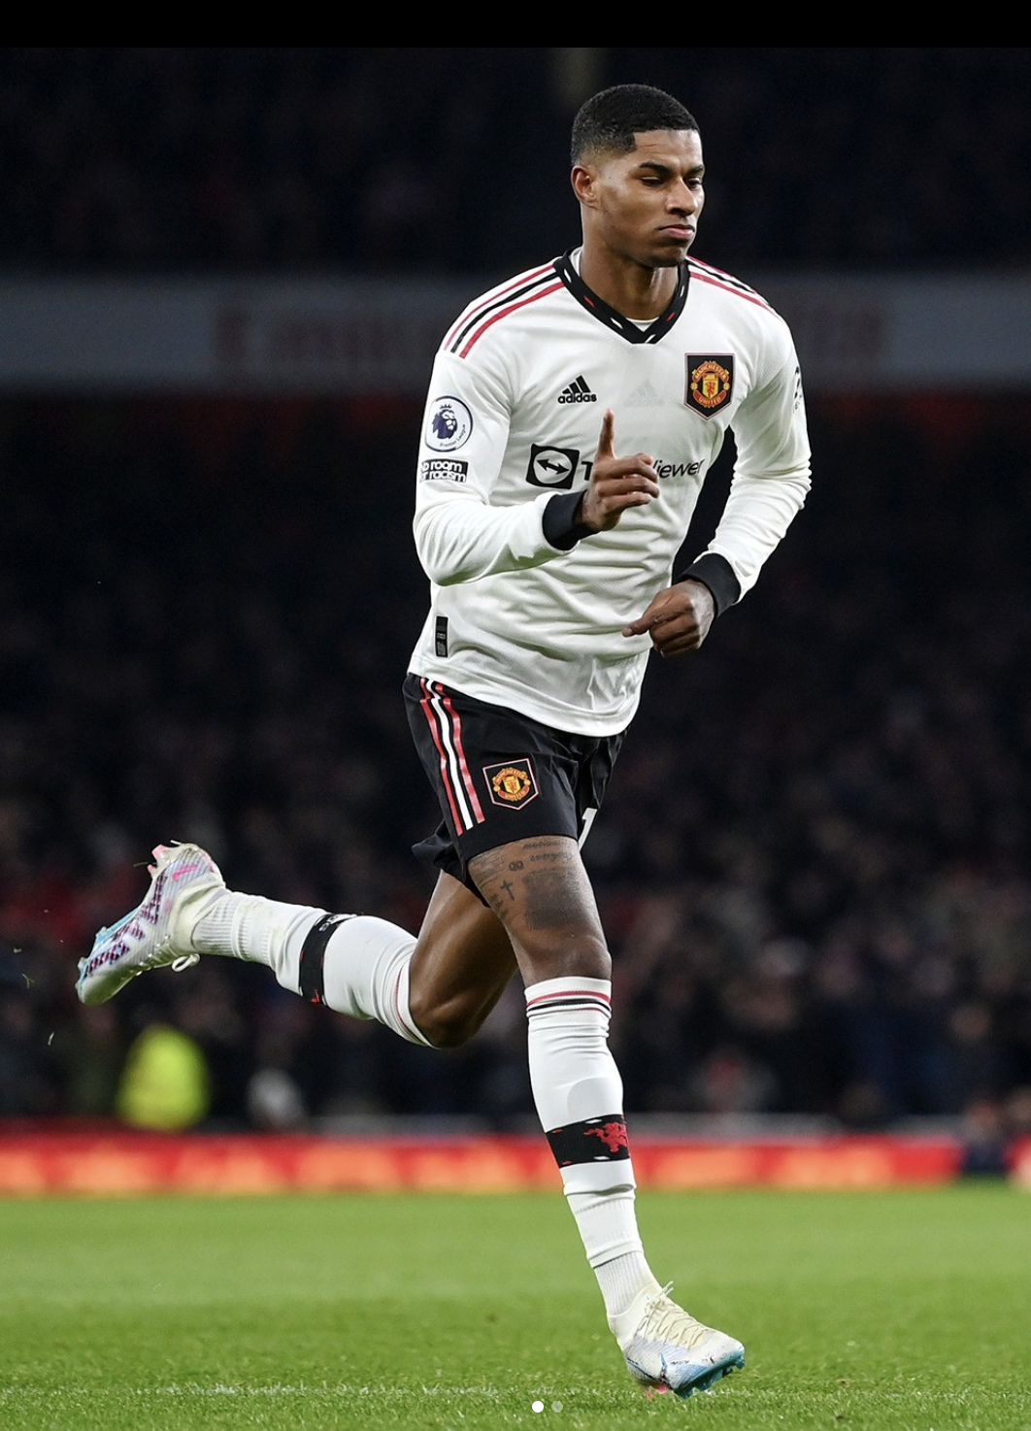

**Caption** : manchester united's marcus rossi celebrates after scoring

**Creative Caption**: "You can never be too rich, too thin, or have too many goals"

"

**Creative hashtags**: # soccer # football # man # ball # kick # goal # teamwork # sports # life #



**Caption(BLIP)** : woman with pink hair holding a cell phone and pointing at it

**Caption(Blip-2)**: a woman holding up her phone with the words boost your personal brand using openapp

**Creative-Caption**: "Don't look back, they're not worth your time."

"Life's too short”

**Creative-hashtags**:

#cellphone #hand #girl #woman #fashion #style #insta #ig #

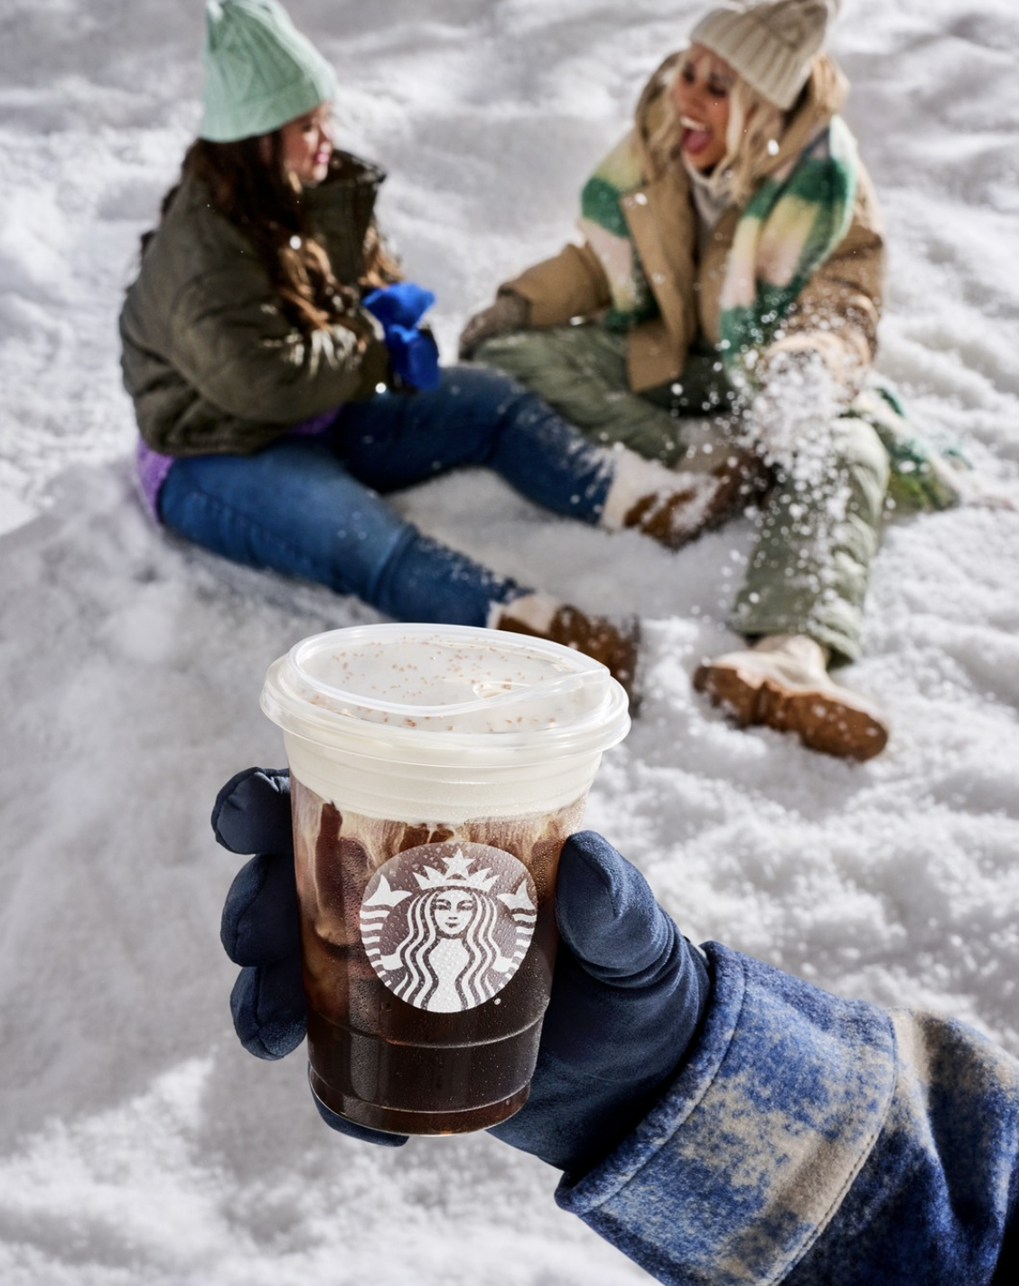

**Caption(BLIP)** : someone is holding a cup of coffee in the snow

**Caption(Blip-2)**: starbucks holiday cups

Creative-Caption:

"But first, coffee"

"Skiing and coffee, what could be better?"

**Creative-Hashtags**:

#cozycoffee #snowday #winterweek #saturdaymorn #datenight

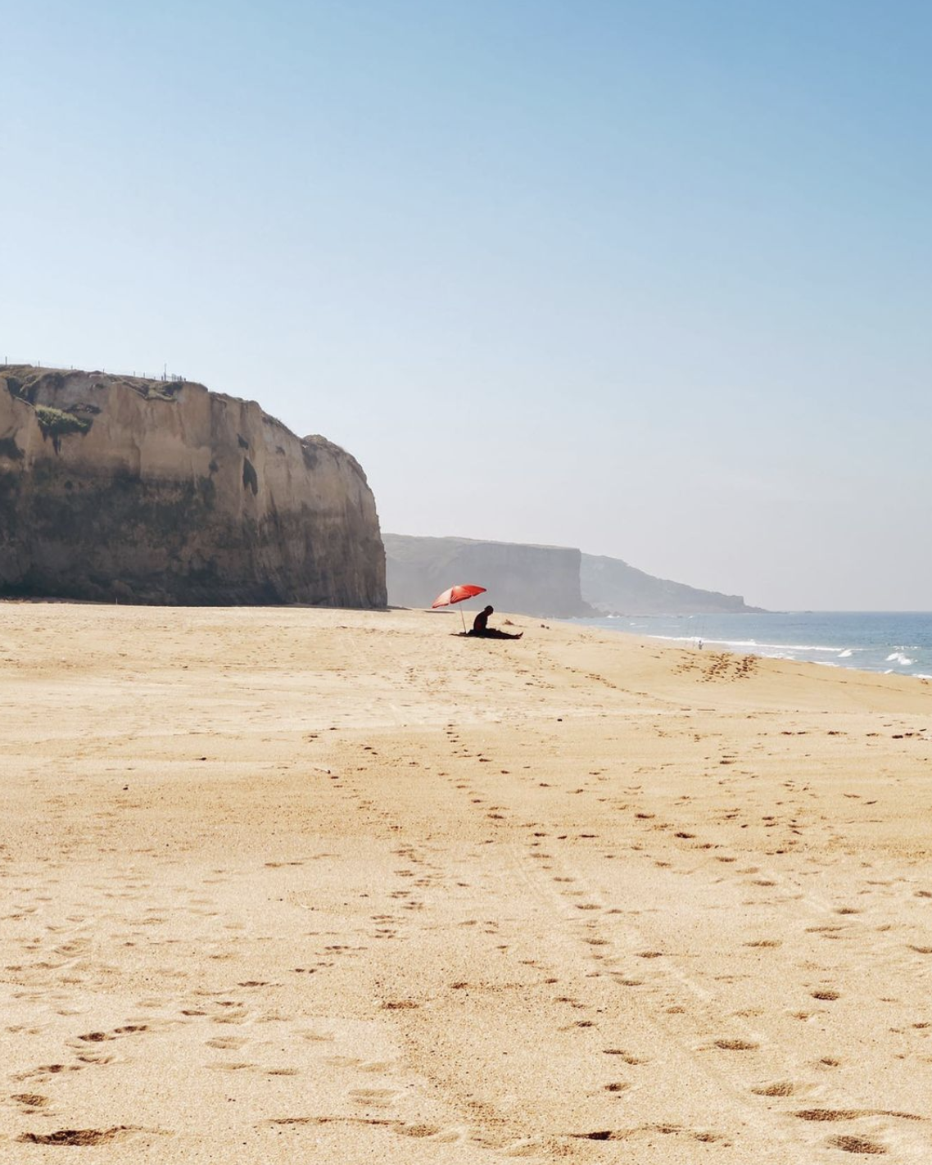

**Caption(BLIP)**: there is a person sitting on the beach with an umbrella

**Caption(BLIP2)** : a person is walking on the beach with an umbrella

**Creative-caption:**

"Surfboard or dinner table? I'm not sure, but I'm loving this beach

**Creative-hashtags**:

#surfer #surfboard #surf #beach #yoga #wellness #